Level 1
Task 4 Logcat basics

Logcat is one of the most powerful tools in Android Studio for real-time debugging and monitoring your app’s behavior. Here's a breakdown of the essentials:
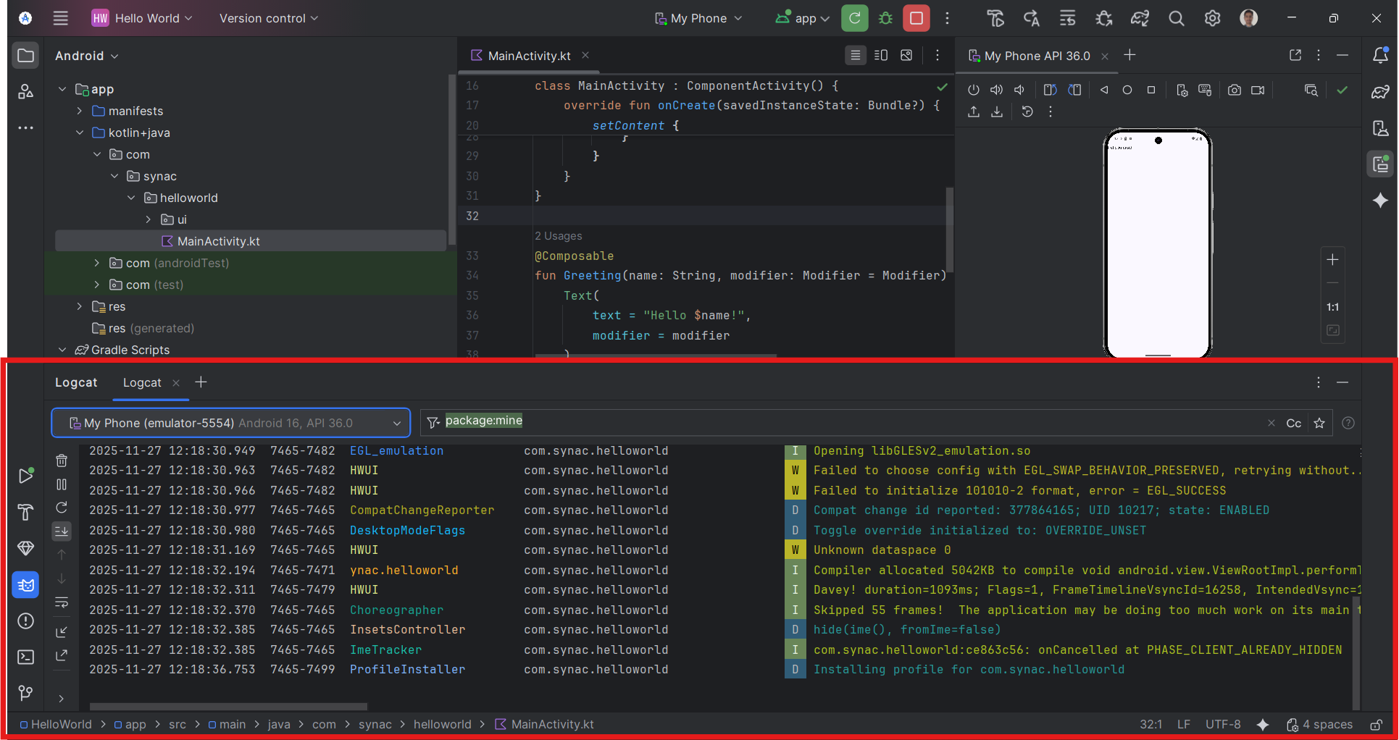
📋 What Is Logcat?
Logcat is a system-wide logging tool that shows messages from:
- Your app (Log.d, Log.e, etc.)
- Android system components
- Runtime errors and stack traces
- Garbage collection, rendering, and performance metrics
It’s like a live feed of everything happening under the hood.
🧠 Logcat Message Format
Each Logcat entry typically includes:
Field | Description
Timestamp | When the log was generated
PID (Process ID) | ID of the process that generated the log
TID (Thread ID) | ID of the thread (optional)
Log Level | Severity (e.g., D, E, I, W, V)
Tag | Identifier for the source (e.g., MainActivity)
Message | The actual log content
Example:
Code
12:18:45.123 10217 D/MainActivity: Hello World launched successfully
🔍 Log Levels
Level | Symbol | Meaning
Verbose | V | All logs, least filtered
Debug | D | Useful for debugging
Info | I | General information
Warning | W | Potential issues
Error | E | Serious problems
Assert | A | Used for assertions (rarely used)
🛠️ How to Use Logcat in Android Studio
✅ Writing Logs in Code
Use Kotlin’s Log class:
kotlin
Log.d("MainActivity", "App started")
Log.e("MainActivity", "Something went wrong")
✅ Filtering Logs
- By log level (e.g., show only errors)
- By package name (e.g., com.synac.helloworld)
- By tag (e.g., MainActivity)
- By search text (e.g., “Skipped frames”)
✅ Viewing Logs
- Open Logcat tab at the bottom of Android Studio
- Select your device/emulator
- Choose your app process
- Apply filters for clarity
🚨 Common Logcat Messages
- "Skipped frames": UI thread is overloaded — optimize rendering or move work off the main thread.
- "Failed to initialize...": Graphics or emulator-related issues.
- "Installing profile...": App optimization during install.
- "Opening libGLESv2_emulation.so": Emulator graphics initialization.

